|  |  |
| --- | --- |
|  | |
|  | The Little Driver – Heated Bed Power Module. An optically isolated power switch for heated beds, hot ends and other non-inductive loads. |

Theory of Operation 2

Using The Trigger (Heated Bed Output) 2

Using The Trigger (Digital Output) 3

Power Supply Configurations (duel supply) 4

Power Supply Configurations (single supply) 4

Over Driving Your Heated Bed 5

Wire Sizing 6

Installation Guide 8

Mounting the board 8

Controlling from an Existing Heated Bed Output 12

Setting up the Little Driver to Replace a Damaged Transistor. 13

Little Driver Electrical Specifications 14

Hole Patters for all board Versions 14

# Theory of Operation

## Using The Trigger (Heated Bed Output)

The Little Driver uses an optically isolated transistor to turn on the MOSFET. This allows the MOSFET to be turned on in a variety of ways. It also allows the heated bed to operate at a different voltage than the main control board.

When the trigger on the Little Driver is supplied with 5mA, the output MOSFET will turn on. If you notice U1 (TLP182) it has 2 LED’s going in opposite directions. This makes the polarity of the heated bed output unimportant. One of the 2 LED’s is going to turn on the output driver no matter how you wire it.

When the LED turns on, the light from the LED causes Q1 to conduct.

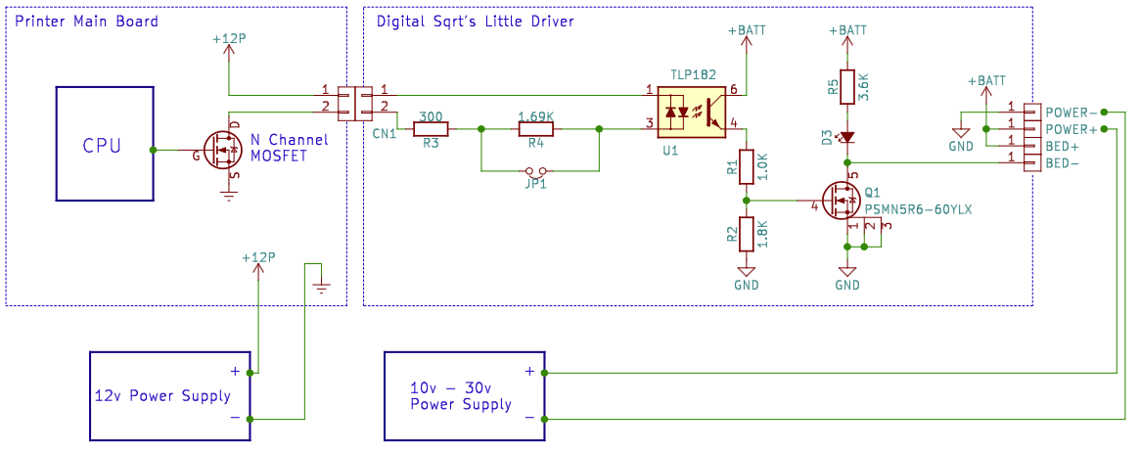

Circuit example: The TLP182’s (U1) LED forward voltage is 1.4v or less. The Printer Main Board power supply is 12v. If JP1 is removed then the input resistance is 1.99K. Voltage across R3/R4 = 12v - 1.4. I1 =VR3/R4 / 1.99K = 5.3mA.

Once TLP182 is conducting the voltage across R2, causes the Power MOSFET to conduct. It also acts as a bleed off resistor when Q1 is off.

Basically, instead of the heated bed being the load on the controller board, the Little Driver’s trigger circuit is. **Most users will be using this configuration.**

**Note:** Some users are confused at the size of CN1. It is a very tiny connector. The heated bed output on the Printer Main Board had large wires installed. Now these very tiny wires are being used. This is perfectly fine to do. The max draw is 50mA.

Even though the output on the Printer Main Board was designed for several amps it will only deliver what is needed,

## Using The Trigger (Digital Output)

Consider the configuration below.

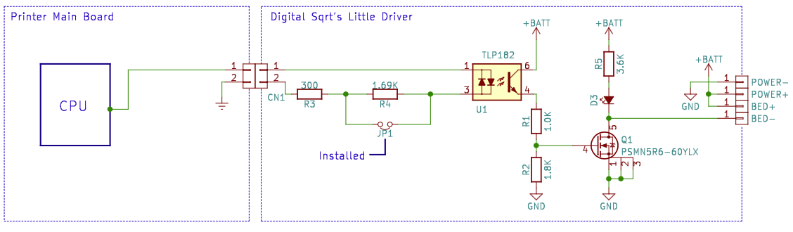

This is the configuration you would use if your Printer Main Board power MOSFETs where damaged.

JP1 should be installed to use a digital output pin from a microprocessor. With JP1 install the little driver will trigger off 3v or 5v logic.

Again, the polarity of CN1 is unimportant. Tie one side of CN1 to the Main Boards ground. Tie the other to the desired CPU pin.

For a 3v system the current draw from the MPU pin will be

I = (3v – 1.4v) / 300 = 5.3mA

In a 5v system.

I = (5v – 1.4v) / 300 = 12mA

## Power Supply Configurations (duel supply)

There are two basic power supply configurations for the Little Driver. Single-Supply and Duel-Supply.

We will start with the Duel-Supply configuration.

Below the power is configured with two power supplies. One of the power supplies is connected to the Printer Main Board and the other is connected to the little diver.



Notice that the ground of the little driver and the Printer Main board are completely different. That is the advantage of optical isolation. Large power surges (like switching a heated bed) don’t affect the Printer Main Board.

The second advantage is that the little driver can use a voltage that is greater than what the Printer Main Board can support.

## Power Supply Configurations (single supply)

Below is how you would configure the printer with one supply.

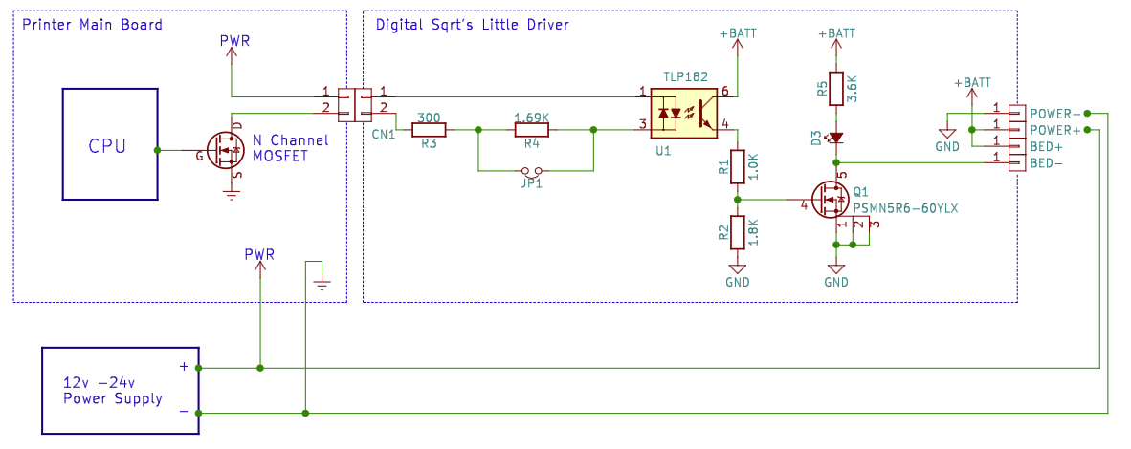

The down side of this configuration is both the little Driver and the Printer Main Board must be rated to use the voltage supplied.

## Over Driving Your Heated Bed

Overdriving your heated bed is using a 12v bed and running it at 24v. Doing so greatly reduces warm up times and increases top end temperature for the bed. In fact, the top end temp will double.

But therein lies one of the big issues. If your heated bed can reach 130 degrees C at 12v; now it will be doing 260 degrees C. **Lead-free solder melts at 188 degrees C.** This sounds like a fire hazard to us. We really don’t recommend doing this.

Now; if you have a heated bed that is toping out at 90 degrees C with 12v. You may want to run it with 16v. Your top end would be right around 120 degrees C. Not nearly as scary; but you could be exceeding the spec’s of your heated bed.

However, we also recognize the Little Driver lends itself to this kind of activity. With that thought, there are some issues that need to be addressed.

1. Your temperature-sensing device can’t save you from disaster. It provides feedback to the control board. If it breaks, the control board can turn on the heated bed to full. If your firmware supports detecting a damaged sensing unit, TURN IT ON!
2. Add a fuse to the power line going to the Little Driver. This is a good idea anyway. But if things go badly, hopefully the fuse will blow before something else bad happens.
3. Add a thermal switch. This is an extra sensor to provide redundancy. Again, if both sensors break then you are back to the original problem.

Again, we don’t recommend this. You are on your own. If your printer catches fire ……. we told you so.

## Wire Sizing

Wire is probably the most misused part in the DIY 3D printer market. We should talk about what ratings are used when specifying the wire to use in an application.

Voltage – This is really specifying how good the insulation is. The higher the voltage, the thicker the insulation is going to be.

Current – This is the one you need to watch. Any given length of wire at a specific gauge is going to have a fixed resistance. As the current increases, more ,and more voltage is dropped across the wire. This also causes a heating effect in the wire. I2 x R = the energy that is being used to heat the wire. This is the same principle that your heated bed works on.

Consider this. If you have a heated bed that is rated for 12v and it draws 12A, its resistance is 1 ohm. Now let’s say the wire that was used to power the bed is .25 Ohms. That is not much. But if you compare it to the heated bed, it is 25%. That is HUGE. 25% of the power intended to heat the bed is lost. These numbers are a bit of an exaggeration but the idea still holds true. Using the right size wire is very important.

Gauge – Digital Sqrt uses the American Wire Gauge. There are lots of standards for wire diameter. For example:

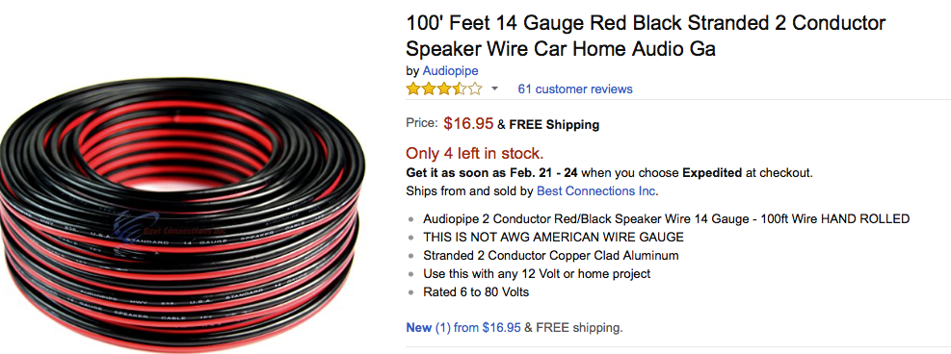

This is really between AWG18-16. (Larger numbers mean smaller wire size.) A 4-foot piece of the wire in the picture is only rated for 15Amps.

The Little Driver is capable of controlling much more than 15 Amps. Make sure you get the right size wire. If the wire you are buying is too small, your heated bed may not perform optimally.

**Wire Sizing (continued)**

What size wire should you be using? That is easy. Consult a wire gauge chart.

There are various wire charts for all kinds of applications. House hold wiring chart would spec a 7 AWG wire for 30 Amps. That is a very large wire.

**Use an automotive wire size chart.** That is closer to the application we have here. The automotive charts suggests a wire between 14-10 AWG. That depends on the length of the wire used. With a 14 AWG wire, there are 6 feet of length before needing to move to the next size gauge. (That’s 3 feet of power and 3 feet of ground.) If your power supply, Little Driver, and heated bed are all very close to each other, 14 AWG will work.

**We recommend 12 AWG wire.** It’s a good balance between line loss and size.

# Installation Guide

## Mounting the board

#### Mounting to 1515 or 2020 Aluminum Extrusion

If you do not have the bracket pictured (or equivalent), you can purchase one at www.Digital-Sqrt.com or print one yourself. File Name: “Al_Ext_Mounting_Bracket.stl”. The file is located at our GitHub repository. See [www.digital-sqrt.com](https://www.digital-sqrt.com) for the link. There are 2 sizes of bracket. The Little Driver Ver 1.9 is slightly larger. Make sure you get the correct bracket.

Step 1

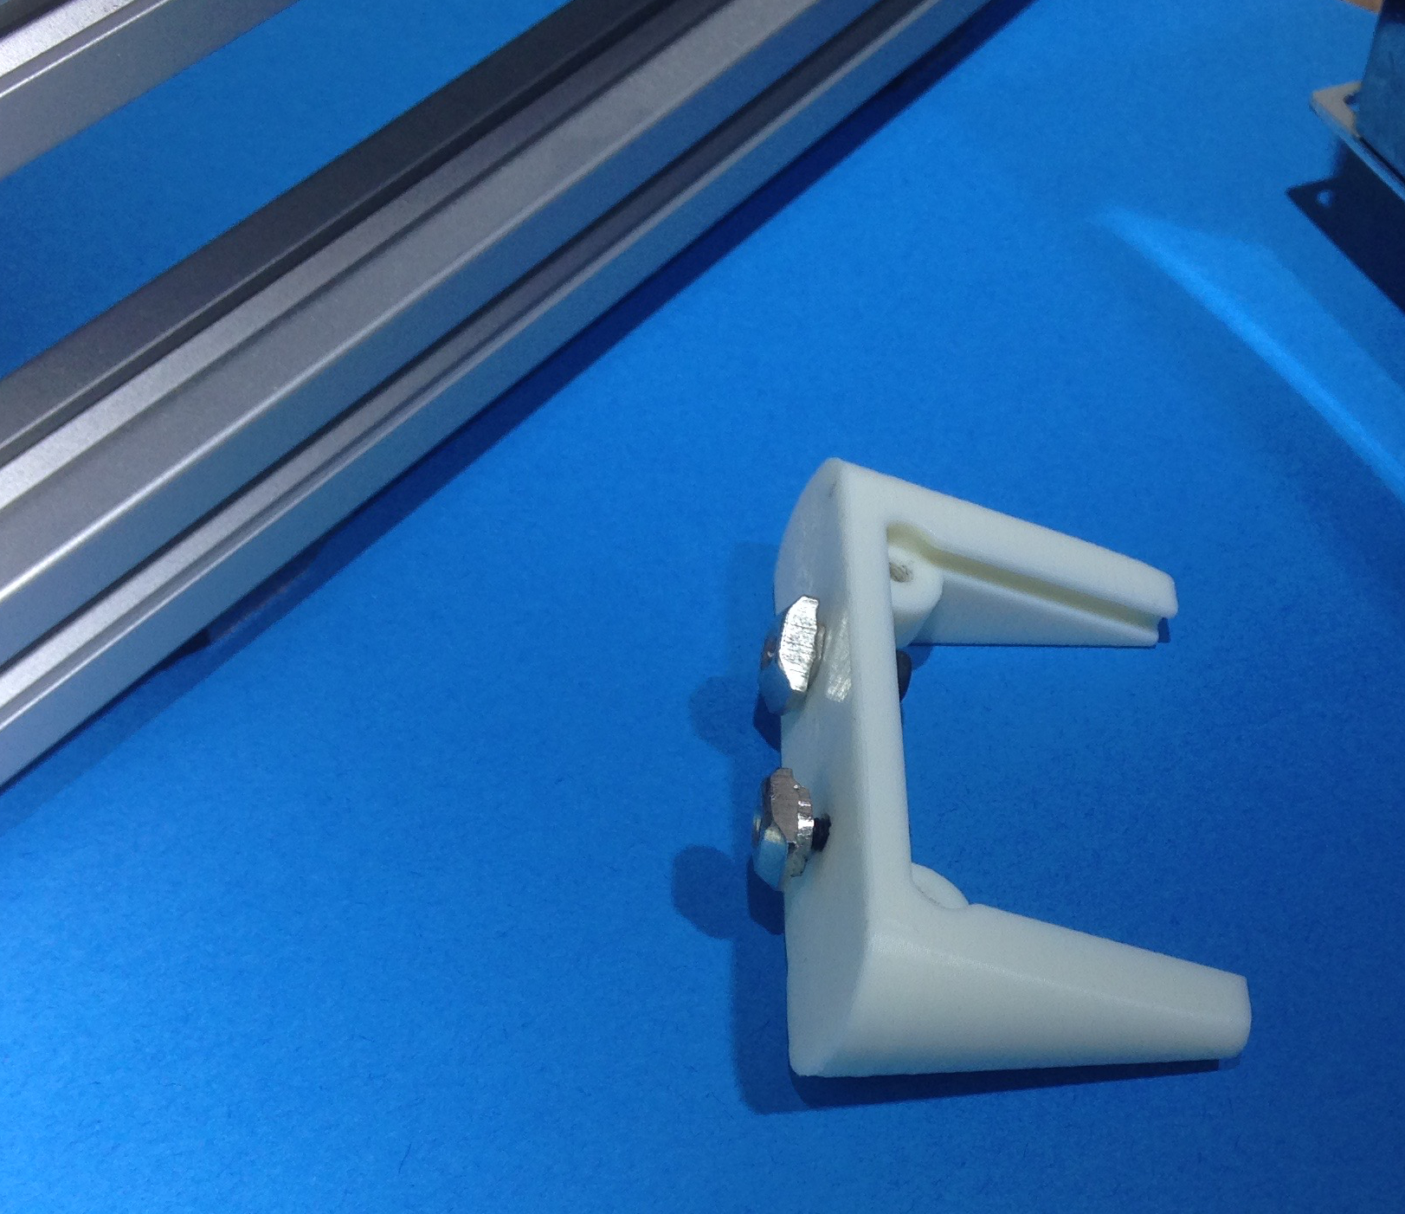

|  |  |
| --- | --- |
|  | Using 2 M3 x 8mm screws, attach the drop-in T-nuts to the mounting bracket. |

Step 2

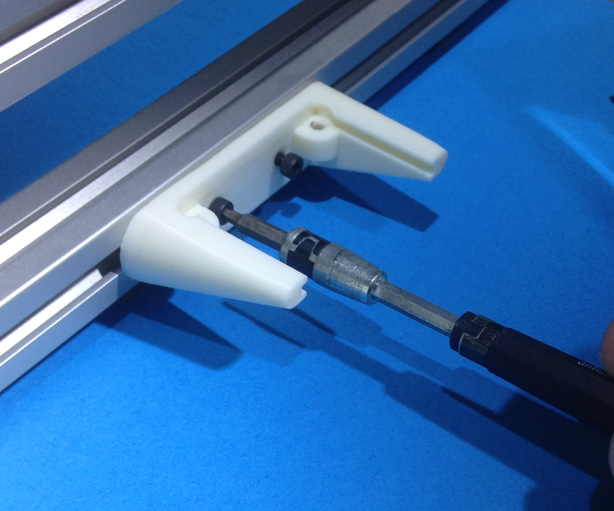

|  |  |
| --- | --- |
|  | Attach the mounting bracket to the aluminum extrusion.  A 20x20mm is pictured here. |

Step 3

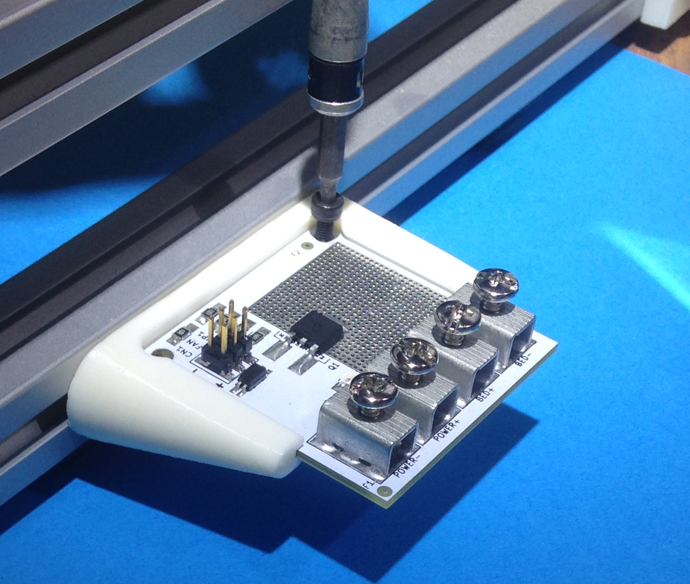

|  |  |
| --- | --- |
|  | Install the Little Driver as shown. Then using 2 M3x8mm screws secure the board in place. Now you can move on to the wiring section |

#### Other Mounting Options

Digital Sqrt also has a universal mounting option. This gives you more options when mounting the Little Driver. If you don’t have the bracket pictured below, one can be obtained from www.digital-sqrt.com. Your other option is to print one yourself. File Name: “Universal_Mounting_Bracket.stl”. The file is located at our GitHub repository. See www.digital-sqrt.com for the link. The Little Driver Ver 1.9 is slightly larger. Make sure you get the correct bracket.

Step 1

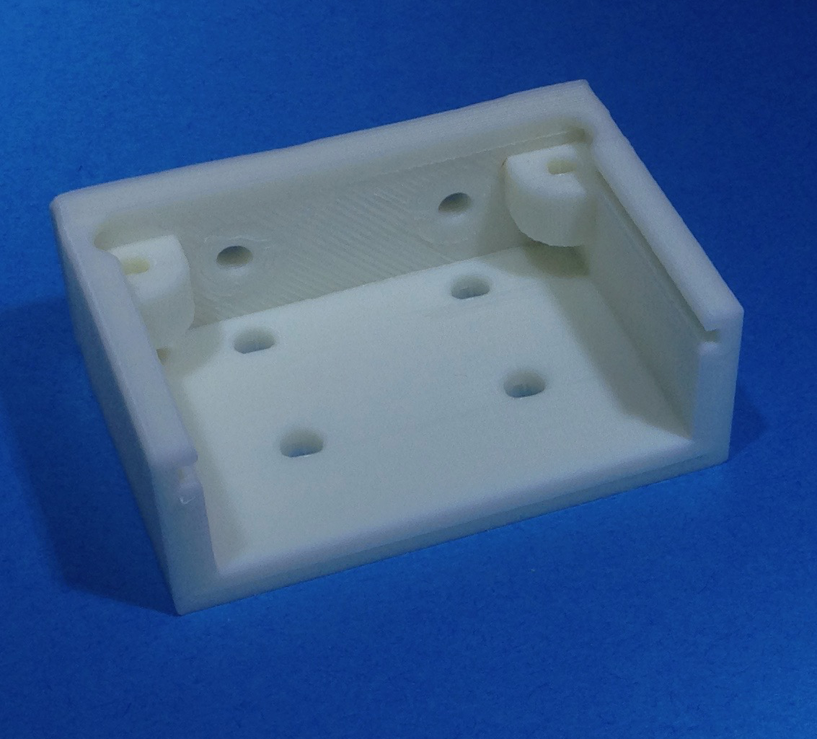

|  |  |
| --- | --- |
|  | This is the universal mounting bracket for the Little Driver. There are several screw holes for various mounting options.  The holes are sized for M3 screws  Mount the bracket in the location you intend for the Little Driver. |

Step 2

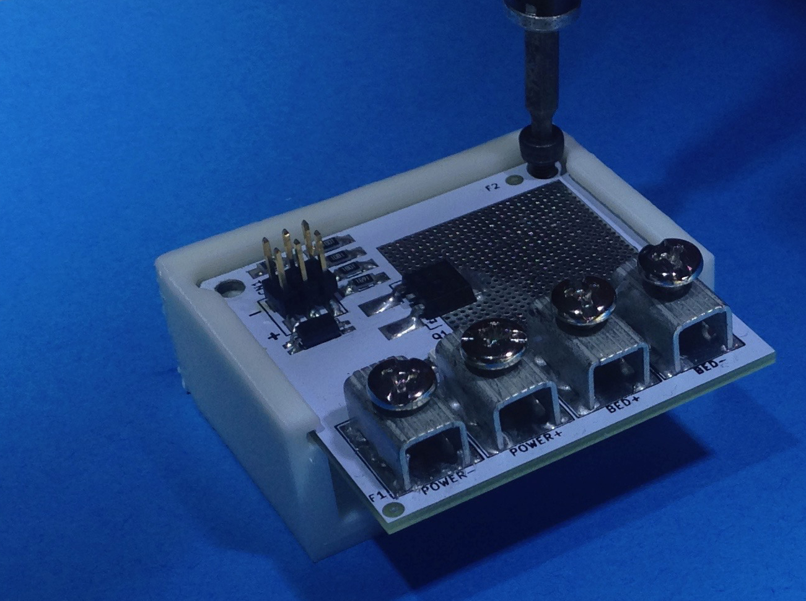

|  |  |
| --- | --- |
|  | Install the Little Driver as shown. Then using 2 M3x8mm screws, secure the board in place.  Now you can move on to the wiring section. |

#### Even more mounting options

|  |  |
| --- | --- |
|  | If the options provided don’t work for you then we have provided the location of all the mounting holes.  The mounting holes are for M3 button cap screws.  Displayed is the 1.9 Driver. |

#### Installation Wiring

These instructions are for board ver 1.5. Ver 1.7 has a different board layout. Ground and power are in different locations. The instructions are the same but the pictures will not match.

If you don’t have your wires prepped for installation, do that now.

If you don’t have a wiring kit, one can be purchased from www.digital-sqrt.com. The bill of materials can be downloaded from our GitHub repository. File Name- “Little_driver_wiring_kit-BOM.csv”. See www.digital-sqrt.com for the link.

Step 1

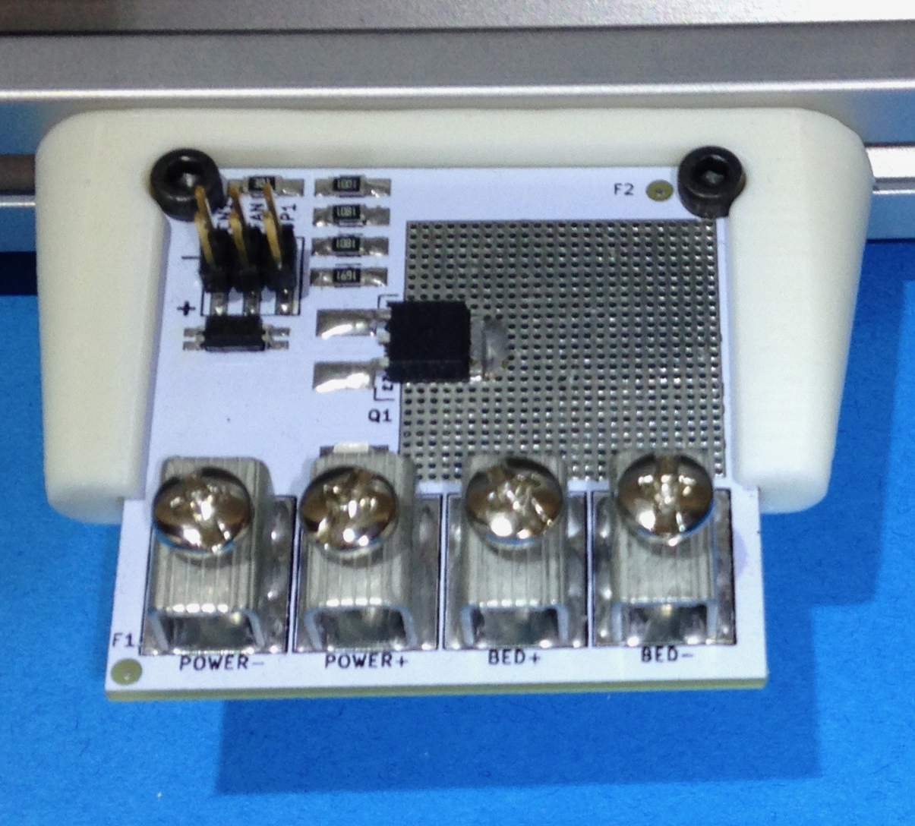

|  |  |
| --- | --- |
|  | Remove the power plug from you power supply. Also ensure that the supply has fully discharged.  Be VERY sure JP1 is NOT installed. |

Step 2

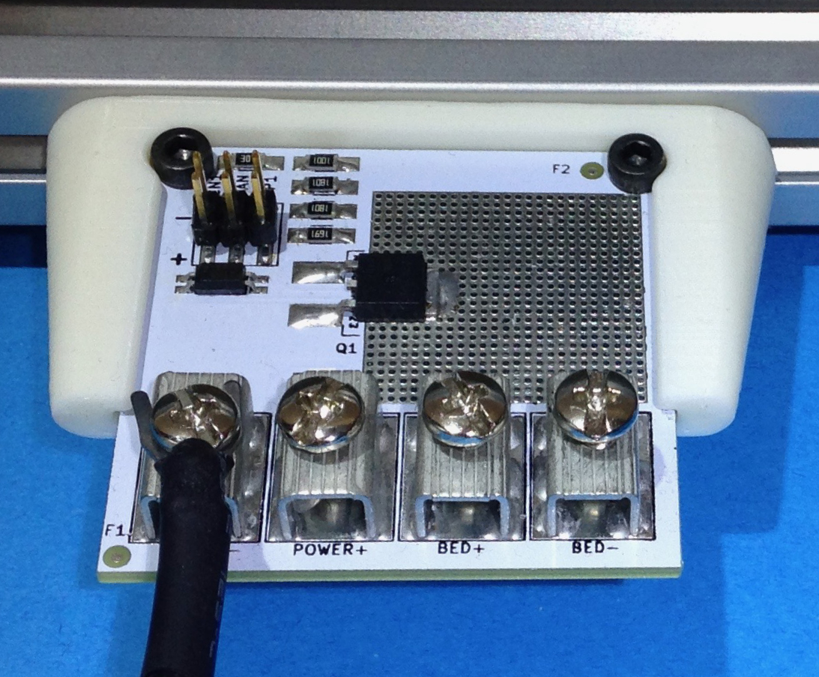

|  |  |
| --- | --- |
|  | Install the Ground side of the power supply where the board is marked “POWER -”.  Power supply wires are marked with black heat shrink. |

**Wiring (continued)**

Step 3

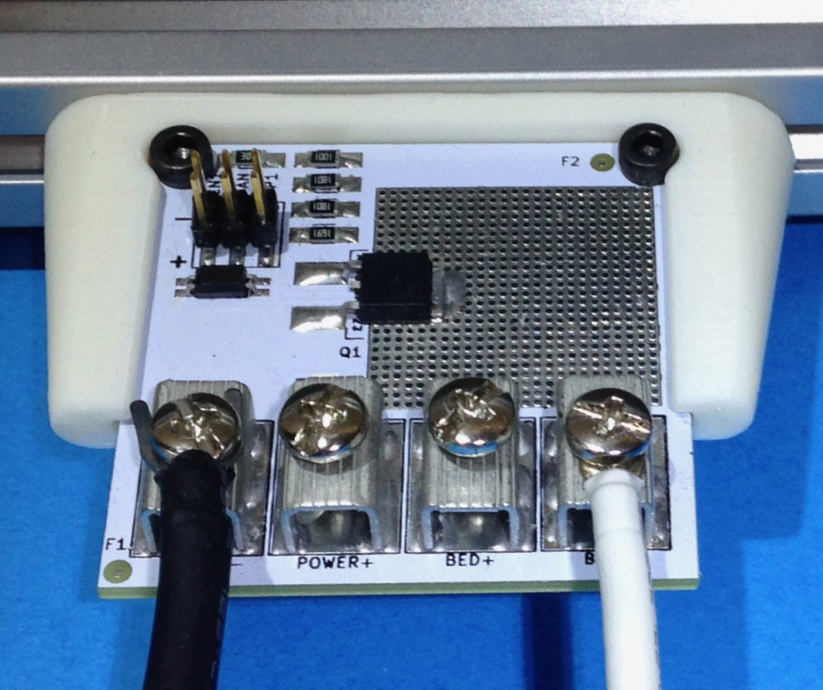

|  |  |
| --- | --- |
|  | Install the Negative side of the heated bed where the board is marked  “BED -”.  Heated bed wires are marked with white heat shrink. |

Step 4

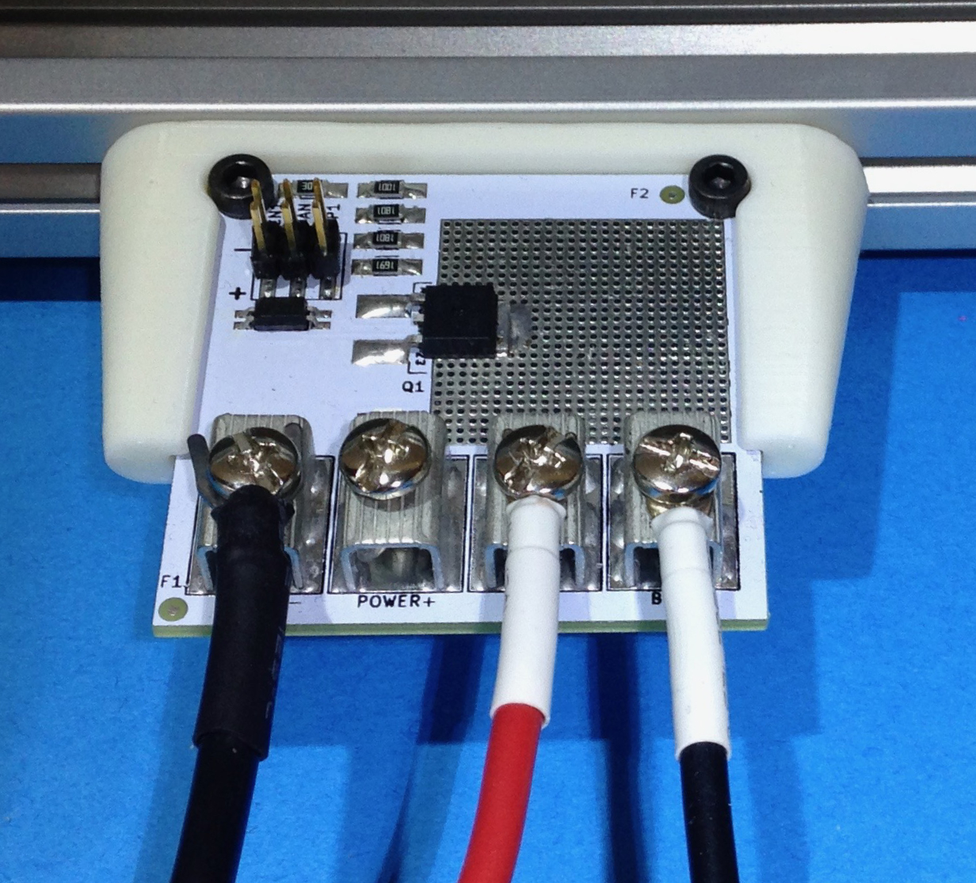

|  |  |
| --- | --- |
|  | Install the Positive side of the heated bed where the board is marked  “BED +”.  Heated bed wires are marked with white heat shrink. |

Step 5

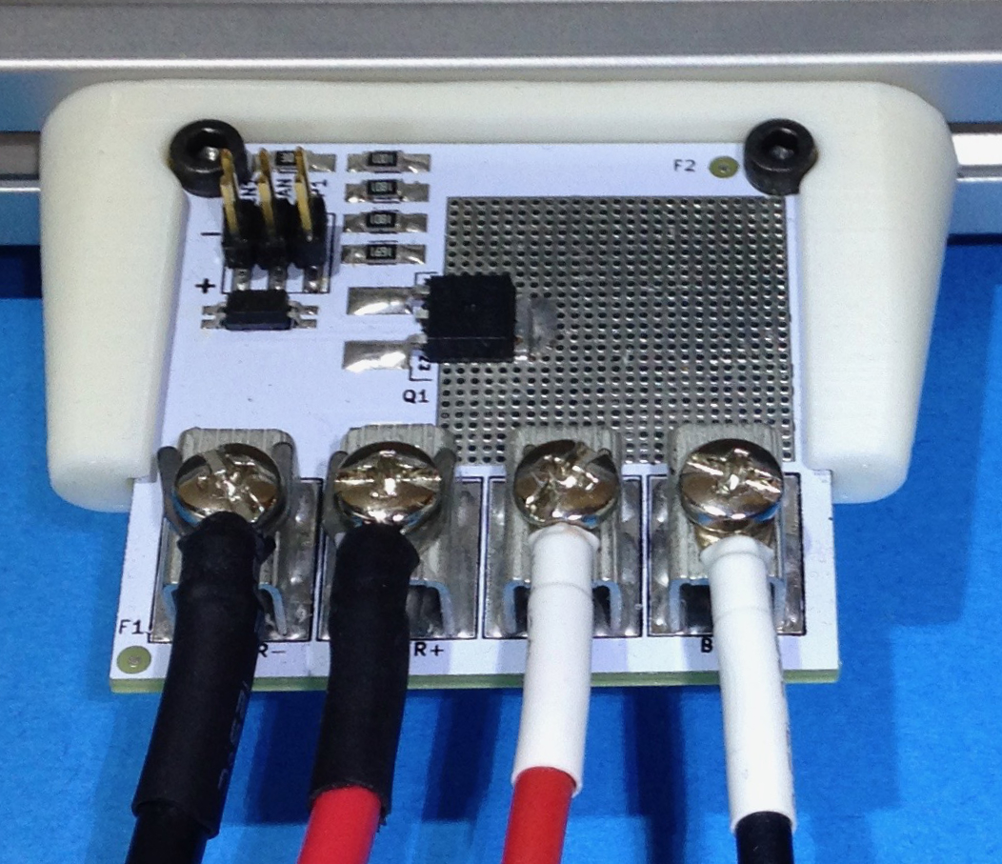

|  |  |
| --- | --- |
|  | Install the Positive side of the power supply where the board is marked “ POWER +”.  Power supply wires are marked with black heat shrink. |

Step 6

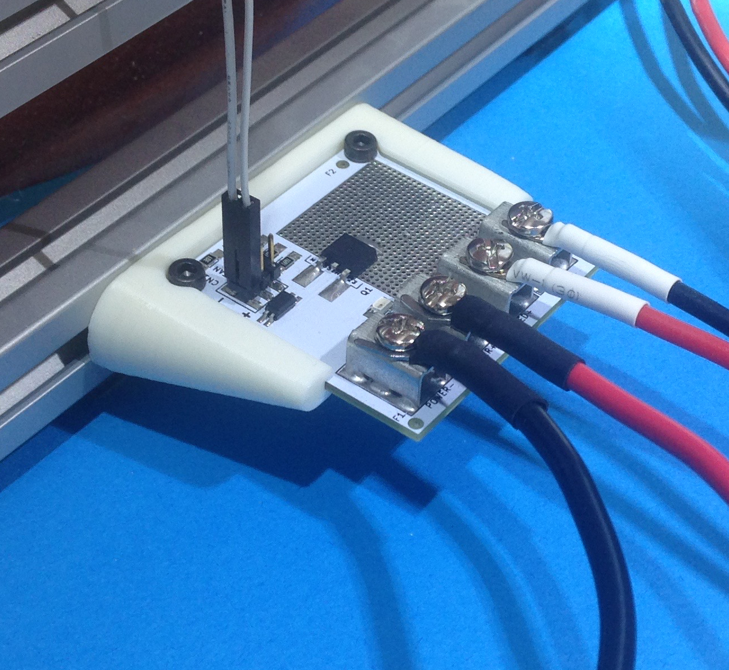

|  |  |
| --- | --- |
|  | Install CN1 cable.  If your cable has the same color wire for both pins, use tape to mark the positive wire. |

## Controlling from an Existing Heated Bed Output

If you are NOT using the existing heated bed output as the control, skip this section.

This method of control uses the heated bed drive transistor that is on your control board. **If JP1 is installed,** you will **destroy the optoisolator** on the board.

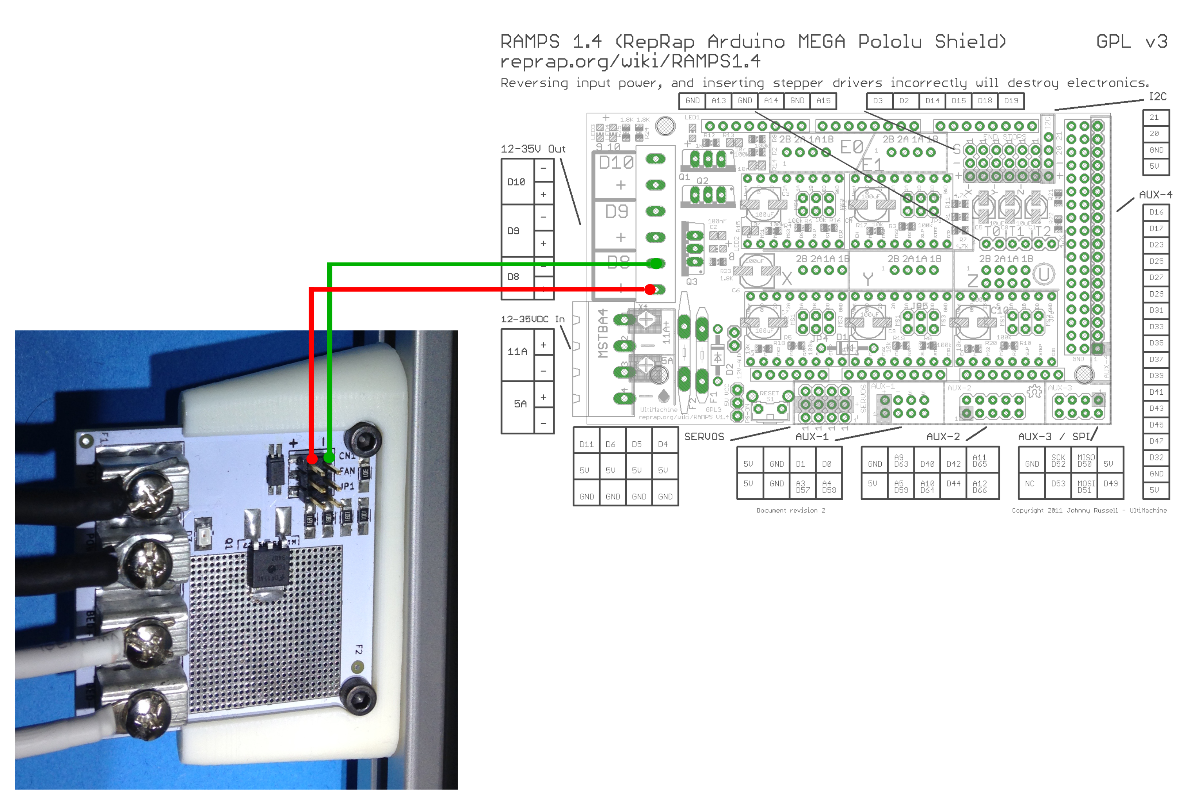

Connect control lines to RAMPS

CN1+ to D8+

CN1- to D8-

To connect the Little Driver to a RAMPS board, connect CN1+ to D8+ and CN1- to D8-.

There are many different control boards on the market. The connections to your board may be slightly different. See the “Theory of Operation” section and review your controller board’s documentation.

**Controlling from a CPU digital output**

This option is a bit tricky. There are so many boards on the market that getting this right is going to be hard.

1. Connect the Little Driver’s CN1- to the controller board’s ground. Let me repeat that. Connect CN1- to the CONTROLLER BOARD’S GROUND.
2. Connect CN1+ to the Digital output from the controller board’s micro.
3. Now install JP1. This is the only case where JP1 can be installed. In fact, the output from the board cannot exceed 7v or the optoisolator will be destroyed.

## Setting up the Little Driver to Replace a Damaged Transistor.

You will need to be an advanced user of your control board in order to make this work.

These instructions assume 3 things

1. That your control board is using some sort of MOSFET to control the heated bed.
2. The MOSFET is a 3 Terminal device. (The tab does not count but may be electrically connected)
3. That the MOSFET is configured as a low side driver.

(MOSFET Source is tied to GND. The Gate is tied to the CPU pin. And the Drain is where the Heated Bed negative terminal was connected.)

This is the way RAMPS 1.4.0 is configured.

**DISCONNECT THE HEATED BED FROM THE CONTROLLER (both wires)**

There are **2 points** you will need to **find**. They are the **Gate** of the transistor and the **Source**.

The **Source** is easy to find. Use a multi-meter in continuity mode and find the MOSFET terminal that is connected to ground. This **is where CN1-** will be **connected**.

Using your multi-meter, find the MOSFET terminal that is connected to the negative side of the heated bed. That terminal will be the Drain. The Drain is not needed. However, the pin that has not been identified is the Gate.

**The Little Driver’s CN1+ will be tied to the Gate.**

**Now JP1 can be installed.**

An easier way to do all this is to read the part number off of the device and look up the data sheet. Many of the controller boards come from China. We have found that identifying Chinese parts can be difficult. If your controller is open-source, you could look at their documentation also.

# Little Driver Electrical Specifications

|  |  |  |  |
| --- | --- | --- | --- |
|  | | Min | Max |
| CN1 INPUT | If | 4mA | 20mA |
| Vin (JP1 installed) |  | 7.0v |
| Vin (JP1 NOT installed) |  | 30.0v |
| Reverse Voltage |  | 6.0v |
| Power Supply | Voltage | 10v | 30v |
| Current |  | 30Amp |
| Output  (@25 deg c) | Voltage | 10v | 30v |
| Current |  | 30Amp |

# Hole Patters for all board Versions

|  |  |
| --- | --- |
| Ver 1.5 | Ver 1.7 |
|  |  |
| Ver 1.8 | |
|  | |